# Exercise 1

Manage Post with PHP and Mysql

Manage post table with construct:

* id: int
* title: varchar
* description: text
* image: varchar
* status int
* create_at: datetime
* update_at: datetime

Requirements:

1. The database & table was created in advance, but if automatically created at first run would be appreciated
2. Project have two area as: frontend (show to user) and backend (manager). Use file, subfolder or params to know what area
3. MVC code
4. Use htaccess rewrite url. (example [http://localhost/mvc/index.php?controller=admin&action=add](http://localhost/mvc_nongdan/index.php?controller=admin&action=add) => [http://localhost/mvc/admin/add](http://localhost/mvc_nongdan/index.php?controller=admin&action=add))
5. Admin gui:

* Grid manage:

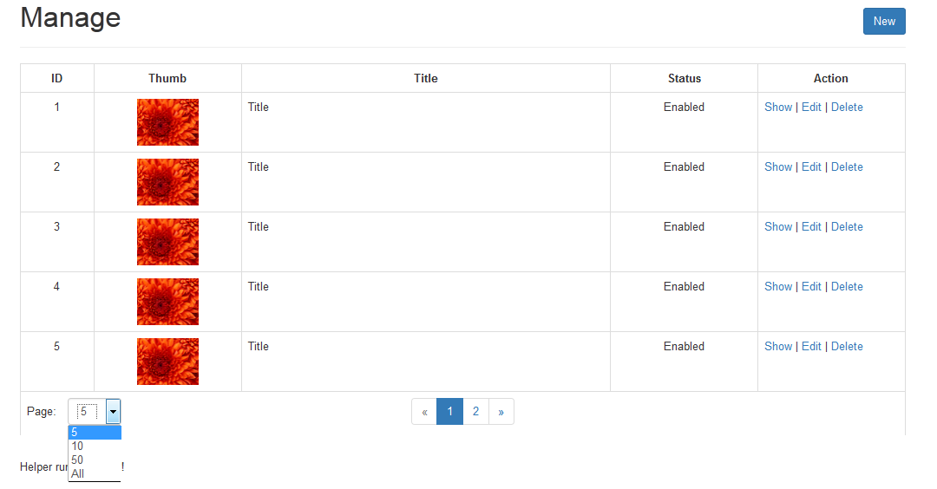

* Edit form

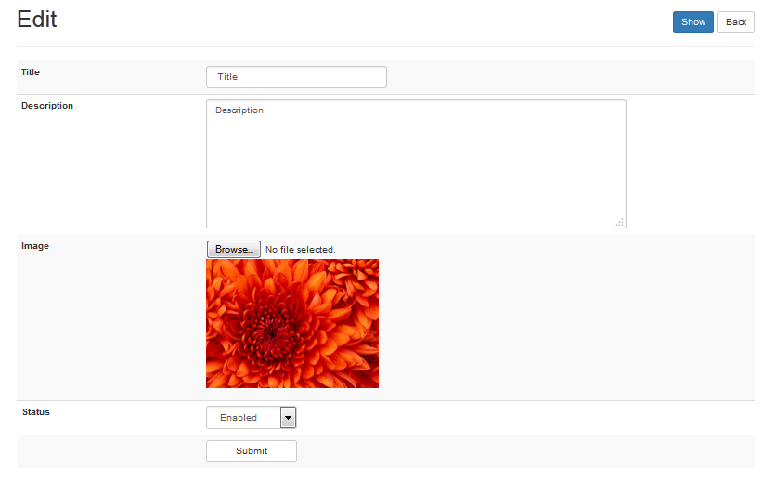

1. Frontend:

* List post:

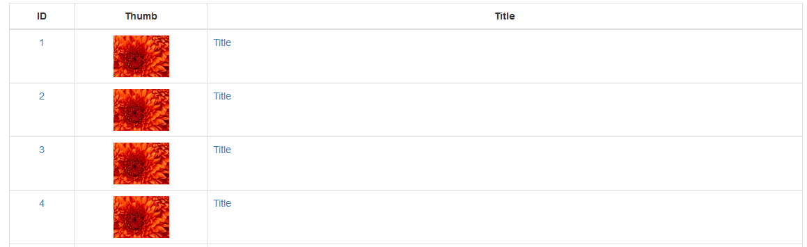

* Show post:



1. Paginator

